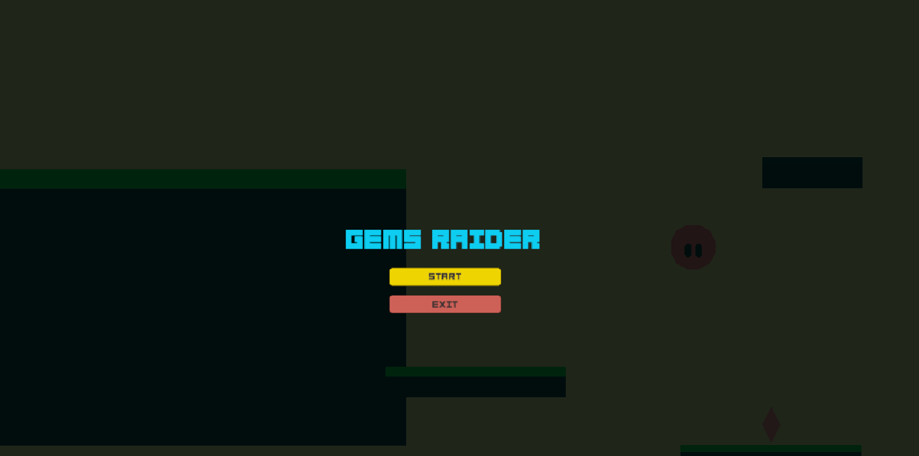

***GEMS RAIDER GAME DESIGN DOCUMENT***